**Some basic question about OOP**

**What is object-oriented programming?**

Object-oriented programming (OOP) is a programming paradigm that focuses on creating **reusable code** structures called objects. It is based on the concept of **objects**, which are instances of classes that **contain data and methods**.

In OOP, programs are designed by defining classes that describe objects and their behaviors. **Classes are like blueprints** or **templates** **that define the properties and methods of the objects they create.**

For example, a class called "Car" might have properties such as "color," "make," and "model," and methods such as "start" and "stop." An object created from the "Car" class would have its own unique values for these properties and would be able to perform the methods defined in the class.

OOP provides several benefits, including **encapsulation**, **abstraction**, **inheritance**, and **polymorphism**. Encapsulation refers to the ability to hide the implementation details of a class from the outside world, which helps to reduce complexity and improve code maintainability. Abstraction allows programmers to focus on the essential features of an object and ignore the irrelevant details. Inheritance enables the creation of new classes based on existing ones, which can save time and effort in coding. Polymorphism allows objects of different classes to be treated as if they were of the same class, which increases flexibility and extensibility in programming.

**Why we need OOP and what it is the advantage of OOP?**

Object-oriented programming (OOP) provides several advantages over other programming paradigms such as procedural programming. Here are some reasons why OOP is useful:

**Code reusability:** OOP allows programmers to create reusable code components called objects, which can be used in different parts of a program or in different programs altogether. This saves time and effort in programming.

**Encapsulation:** OOP enables programmers to hide the implementation details of a class from the outside world, which helps to reduce complexity and improve code maintainability.

**Abstraction:** OOP allows programmers to focus on the essential features of an object and ignore the irrelevant details. This helps to simplify the design of complex programs.

**Inheritance:** OOP enables the creation of new classes based on existing ones, which can save time and effort in coding. Inheritance also promotes code reuse and reduces code duplication.

**Polymorphism:** OOP allows objects of different classes to be treated as if they were of the same class, which increases flexibility and extensibility in programming.

**Modularity:** OOP promotes modular design, which enables programmers to divide a program into smaller, more manageable components. This helps to simplify program design and maintenance.

**What is class and what is object in OOP?**

In object-oriented programming (OOP), a class is a blueprint or template for creating objects, while an object is an instance of a class.

**A class defines the properties and methods of an object.** It is a user-defined data type that encapsulates data and functions into a single unit. The properties of a class are also known as attributes or member variables, while the methods are also known as member functions or operations. The class specifies the behavior of the objects that are created from it.

On the other hand, an object is a specific instance of a class. It has its own unique set of properties and can perform the methods defined in the class. When an object is created, memory is allocated to store its properties and methods. Each object has its own set of values for the properties defined in the class.

For example, if we have a class called "Car", we can create multiple objects of that class such as "Toyota Corolla", "Honda Civic", "Ford Mustang", and so on. Each object will have its own unique set of properties such as color, make, model, and so on.

In summary, a class is a blueprint for creating objects, while an object is a specific instance of a class with its own unique set of properties and methods.

**What is constructor in OOP?**

In object-oriented programming (OOP), a **constructor is a special method** **that is called when an object of a class is created**. The purpose of the constructor is to **initialize the properties of the object to their default values** or to values passed as arguments.

The constructor has the same name as the class. It is automatically called when an object is created. The constructor can be used to set the initial state of an object and to perform any necessary setup operations. **For example: Database connection.**

There are two types of constructors: default constructors and parameterized constructors. A default constructor is a constructor that takes no arguments and initializes the properties of the object to their default values. A parameterized constructor is a constructor that takes one or more arguments and initializes the properties of the object to the values passed as arguments.

**What is inheritance and what are the types of inheritance?**

In object-oriented programming (OOP), inheritance is a mechanism that allows a new class to be based on an existing class, inheriting its properties and methods. The existing class is called the base class or parent class, while the new class is called the derived class or child class.

Inheritance allows the derived class to reuse code from the base class, reducing the amount of code that needs to be written. It also promotes code reuse, improves code organization and maintenance, and simplifies program design.

There are different types of inheritance:

**Single inheritance:** A derived class is derived from a single base class. This is the most common type of inheritance.

**Multilevel inheritance:** A derived class is derived from a base class, which is also derived from another base class.

**Hierarchical inheritance:** Multiple derived classes are derived from a single base class.

**Multiple inheritance:** A derived class is derived from two or more base classes. This is not supported by all programming languages and can be complex to manage.

**Hybrid inheritance:** A combination of multiple inheritance and hierarchical inheritance.

**What is Encapsulation?**

Encapsulation is a fundamental concept in object-oriented programming (OOP) that refers to **the practice of hiding the internal details of an object from the outside world, and exposing only what is necessary for its use.**

In other words, encapsulation is the process of **wrapping data and behavior** (i.e., methods) into a single unit, and restricting access to the internal state of an object, such that it can only be modified through a defined set of methods.

This helps to achieve several benefits, including improved code maintainability, better security, and reduced complexity by separating the responsibilities of different parts of the program. Additionally, encapsulation allows for the creation of reusable code components that can be used in different parts of the program, without needing to worry about the details of how they are implemented.

In summary, encapsulation is an important concept in OOP that helps to ensure that the internal state of an object is protected and controlled, and that the interface for interacting with the object is clear and consistent.

**What is Abstraction?**

Abstraction is another fundamental concept in object-oriented programming (OOP) that refers to the **practice of reducing complexity by focusing only on the essential features of an object**, while ignoring the non-essential or irrelevant details.

**In other words, abstraction is the process of defining a set of characteristics or properties that are common to a group of objects**, and creating a simplified representation of those objects that focuses on those common features. This simplified representation is often referred to as an abstraction, and it allows for easier comprehension and management of complex systems.

Abstraction is often achieved through the use of abstract classes or interfaces, which define a set of methods or properties that are common to a group of related objects, without specifying their implementation details. By using abstraction, we can create a hierarchy of classes that inherit from these abstract classes or implement these interfaces, and customize their behavior to meet specific requirements.

One of the main benefits of abstraction is that it allows us to design programs that are easier to understand, maintain, and modify over time. Additionally, abstraction also helps to reduce coupling between different parts of the program, which can lead to improved scalability, flexibility, and extensibility.

**What is Abstract Class in OOP and why we need it?**

An abstract class is a class that contains at least one abstract method. An abstract method is a method that is declared, but not implemented in the code.

In object-oriented programming (OOP), an abstract class is a class that cannot be instantiated directly and serves as a base or template for other classes. Abstract classes contain abstract methods, which are methods without implementation, that must be implemented in the derived classes that inherit from them.

**We need abstract classes in OOP for several reasons:**

**To provide a common interface:** Abstract classes allow us to define a common interface for a group of related classes. By defining common methods and properties in the abstract class, we can ensure that all derived classes implement the same methods and properties in a consistent manner.

**To enforce a contract:** Abstract classes can be used to enforce a contract between the base class and derived classes. By defining abstract methods in the abstract class, we can ensure that derived classes implement these methods in a specific way.

**To provide a level of abstraction:** Abstract classes can provide a level of abstraction and hide implementation details from the user. By defining abstract methods and properties, we can define the behavior of the class without specifying the details of how it works.

**To support polymorphism:** Abstract classes are often used to support polymorphism. Polymorphism allows objects of different classes to be treated as if they were of the same type. By defining a common interface in an abstract class, we can create a hierarchy of classes that can be treated as if they were of the same type.

In summary, abstract classes in OOP provide a way to define a common interface for a group of related classes, enforce a contract between the base class and derived classes, provide a level of abstraction, and support polymorphism.

**What is polymorphism?**

Polymorphism is another fundamental concept in object-oriented programming (OOP) that refers to **the ability of objects to take on different forms, depending on the context in which they are used**.

In other words, **polymorphism allows objects of different classes to be treated as if they were of the same type, by providing a common interface that can be used to interact with them**. This allows for greater flexibility and reusability of code, as different objects can be used interchangeably in different parts of the program.

Polymorphism can be achieved in several ways, including **method overloading** and **method overriding**. Method overloading refers to the practice of defining multiple methods with the same name in a class, but with different parameters. This allows for the same method name to be used for different purposes, depending on the type and number of parameters that are passed to it.

Method overriding, on the other hand, refers to the practice of redefining a method in a subclass that was originally defined in its parent class. This allows the subclass to provide its own implementation of the method, while still being able to use the same method name and signature as the parent class.

By using polymorphism, we can create programs that are more modular, flexible, and extensible, as different objects can be added or removed from the program without affecting the overall functionality of the program. Additionally, polymorphism can also help to improve code readability, by providing a consistent and intuitive interface for interacting with objects of different classes.

**What is method overriding?**

Method overriding is a concept in object-oriented programming (OOP) where a **subclass** provides a new implementation of a method that is **already defined in its parent class**. **The method in the subclass must have the same name, parameters, and return type as the method in the parent class, but it can provide a different implementation**.

Here's an example of method overriding in Python:

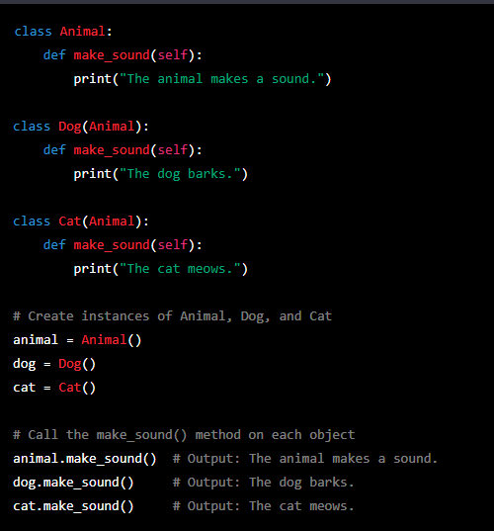

In this example, we have an Animal class with a make_sound() method that prints a generic message. We then define two subclasses, Dog and Cat, that override the make_sound() method with their own implementations.

When we create instances of the Animal, Dog, and Cat classes, and call the make_sound() method on each object, we get different outputs depending on the class of the object. This demonstrates the concept of method overriding, where the subclass provides a new implementation of a method that is already defined in its parent class.

**What is method overloading?**

Method overloading is a concept in object-oriented programming (OOP) where a **class can have multiple methods with the same name but different parameters**. The methods must have the **same name**, but their **parameters should be different in number or type**.

However, unlike some other programming languages, Python does not support method overloading in the traditional sense. In Python, you can define a method with a default parameter value, which can be used to achieve similar functionality as method overloading.

Here's an example of how you can achieve method overloading-like functionality in Python:

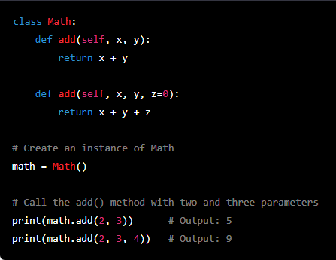

In this example, we have a Math class with two add() methods. The first method takes two parameters and returns their sum, while the second method takes three parameters (with a default value of 0 for the third parameter) and returns their sum.

When we create an instance of the Math class and call the add() method with two or three parameters, we get different outputs depending on the number of parameters passed. This demonstrates the functionality of method overloading, where the same method name can be used to perform different operations depending on the number or types of parameters passed.

**What is operator overloading?**

Operator overloading is a concept in object-oriented programming (OOP) that allows operators such as +, -, *, /, etc. to be redefined for custom classes. This enables objects of custom classes to behave like built-in types when used with operators.

In Python, operator overloading is achieved by defining special methods in a class that correspond to the operator being used. For example, the + operator can be overloaded by defining a method called add() in the class.

Here's an example of operator overloading in Python:

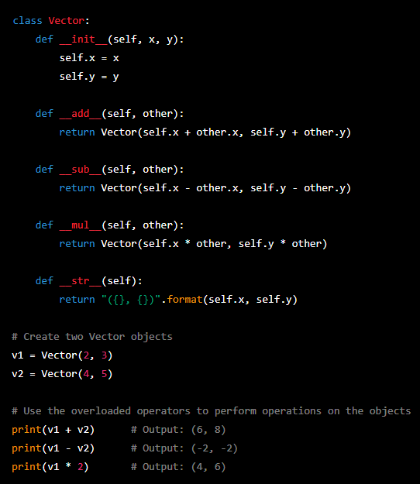

In this example, we have a Vector class that represents a two-dimensional vector with x and y components. We define special methods such as add(), sub(), and mul() to overload the +, -, and * operators respectively. We also define a str() method to allow us to print the objects in a readable format.

When we create two Vector objects and use the overloaded operators to perform operations on them, we get the expected results. This demonstrates the functionality of operator overloading, where operators can be redefined for custom classes to provide a more intuitive and flexible interface for working with objects.